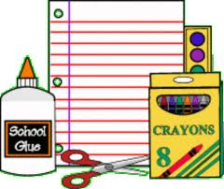
Mrs. Mehlenbacher’s First Grade Supply List 2019-2020
Everyone | Boys | Girls
4 pack or larger of black Expo markers | Kleenex | Ream of white paper
Clorox Wipes | 1 box of Ticonderoga pencils | Pink erasers
Glue stick pack | 1 box of quart size plastic bags | 1 box of gallon size plastic bags

*4 Composition notebooks - wide ruled please
*3 double pocket plastic folders (green, yellow, red)
Pair of scissors
One box of colored pencils
A pencil sharpener with a lid
A pair of headphones - please label
A large pencil pouch (NO boxes please) Label please
*indicates I will label these items*

